Docobrainstormguide:

Main topic

Subtopics

Five Key questions

Angle (point of view)

Unique selling point(s)

Three possible titles

Unique skills/talents of group members + how you might use them

Other people to get involved and how/why

Style of documentary

People to interview

Key interview questions

Interview location/background

What kind of archival footage could be useful?

What kind of music?

What other footage might you need?

What still images could you use?

How will you use:
- long shots

- medium shots

- close-ups

- panning shots

- hand-held

- up-shots

- down-shots

How might you use text?

What problems/obstacles do you expect?

docoplan&script

Film crew: ____________________________________________________

Title: ____________________________________________________

Topic: ____________________________________________________

Angle: ____________________________________________________

Summary:

Script (must include the intro and conclusion and at least one scene in between):

__________________________________________________________________

__________________________________________________________________

__________________________________________________________________

__________________________________________________________________

__________________________________________________________________

__________________________________________________________________

__________________________________________________________________

__________________________________________________________________

__________________________________________________________________

__________________________________________________________________

__________________________________________________________________

__________________________________________________________________

__________________________________________________________________

__________________________________________________________________

__________________________________________________________________

__________________________________________________________________

__________________________________________________________________

__________________________________________________________________

__________________________________________________________________

__________________________________________________________________

__________________________________________________________________

__________________________________________________________________

__________________________________________________________________

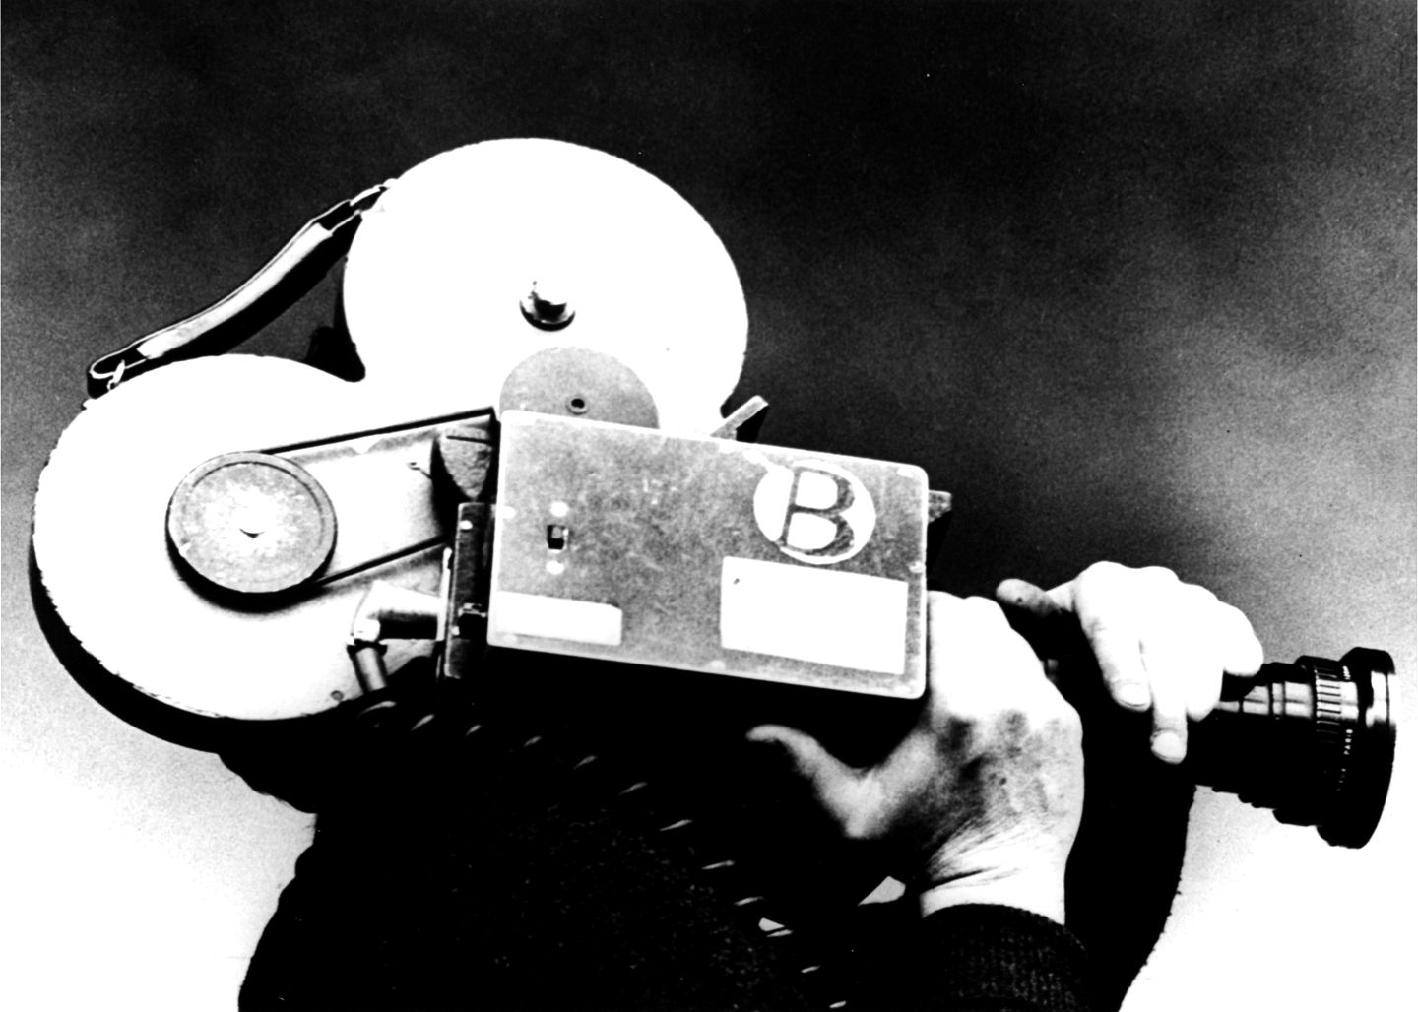
__________________________________________________________________Year 9/10 Media Studies Documentary task

In groups of 3 you will produce a short 3-5 minute television documentary on a topic of your choosing. Your documentary should aim to entertain your audience, but also provide educational and informative content. You will also need to draw on your knowledge of the key conventions of documentary.

Part 1: Planning
- Decide on your topic or issue
You only have 3-5 minutes, so pick a topic that is manageable. In order to do this, it is suggested you use a flow chart or mind map to narrow the focus of your documentary. You will also need to consider what message you want to convey to your audience about the topic or issue.
- Decide on a mode and target audience that is appropriate for your topic
- Research your topic
- Produce a storyboard and script for your documentary
The storyboard and script need to have a narrative structure, as well as an indication of where and how each scene may be filmed, and a list any props or costumes you may need.

Note: The script, storyboard and any other supporting planning material should be submitted at the conclusion of this unit, as it will form part of your assessment.

Part 2: Filming and Editing
- Show your teacher the completed script and storyboard.
- Film your documentary and edit on iMovie adding soundtrack, transitions etc.
- Export your final product Make sure your file name includes the name of everyone in your group.

Note: You should be constantly referring to your script and storyboard during this stage.

Part 3: Evaluation
You will need to individually reflect upon your final product and the production process. You will need to include:
- what worked and didn’t work as well as expected
- justification of decisions you made regarding editing and planning
- whether or not you adhered to your script and storyboard – if not, explain what changes you needed to make and why
- a short critical evaluation of your documentary

This evaluation should be 250-300 words in length.

Refer to reverse side of sheet for assessment and marking criteria.

Due date: Thursday week 2 Term 4

